Intro to Web Dev
Sitemap
- A diagram that contains all the pages for a site and shows how each page relates to the others
-a top-down planning tool
- shows how user can navigate from one page to another
-A common nav bar would allow user to get to any of the first-tier pages from anywhere on the site.
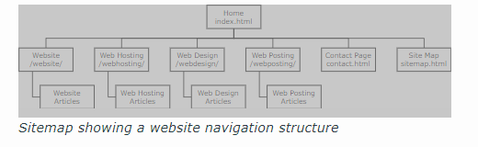
Wireframes
A schematic of a page on the site. Shows arrangement of all the components (navigation, forms, charts, buttons, images etc) on the page.
Some site use same template for every page, others use a handful of different layout templates. Developers use wireframes to make actual pages

Elements, structures & attributes
Elements are written using angle brackets to start and end them, with a lower-case descriptive name
<html></html>
-designed to contain content or other elements between the opening and closing tags.
- must have open and close to be valid

Empty Elements
<hr/> is valid as a single tag. They represent a single component in the document and are a self-closing tag
An element tag is not displayed by the browser, rather it tells the browser how to display the content they contain or the components they represent.

HTML Document Structure
an HTML document is a collection of nested HTML elements that describe the content of a page to be displayed by a browser.
Head is primarily for title of the page, meta info, script sections, style declarations
Body used to describe portion of page the browser will display to user, aka the content

DOCTYPE
Used to tell the browser which HTML specification to conform to
Attributes
A key value pair, to give additional information, context, or identity to an element
Ex. <div id = “ContentArea” ></div>
Later CSS and JavaScript will locate and manipulate this unique element.

